﻿Newsletter for the Fisher/Bygland Lutheran Parish ~ May 2026
From the Secretary’s desk...
THE MESSENGERMESSEMESSENGER

Growing in Faith together
Fisher Bygland Parish
We are affiliated with the Evangelical Lutheran Church in America (ELCA) and a member of the Northwestern Minnesota Synod. We are a two-point parish, serving the members of Fisher and Bygland
Bygland Lutheran Church
40976 235th St. SW
Fisher, MN 56723
218893-4243
Mission
“We are God’s work in progress, with hearts lifted to God in trust and praise and with hands extended to serve in Jesus’ name.”

Fisher Lutheran Church
209 2nd St. S.
Fisher, MN 56723
218-891-4632
Mission
As children of God, we invite all people to journey with us as we worship, grow in faith and serve in Jesus’ name.
Location

Email
office@fisherbygland.org
pastor@fisherbygland.org

Worship Services
9:00 AM and 11:00 AM
Fisher and Bygland have alternating times each week.
Please view the calendar for worship times.
Services streamed online via Facebook

As we move into the month of May, we are surrounded by signs of new life. Fields are being prepared, seeds are being planted, and we begin to see the beauty of God’s creation coming alive once again. This season reminds us that growth often happens quietly, beneath the surface, and before it is ever seen. The same is true in our faith.

In our parish, we have witnessed many moments of growth this past season. From our Sunday school students who have learned and shared their faith in meaningful ways. Our youth and families serving others through projects like Feed My Starving Children and Adopt-a-Highway. And now, as we celebrate our graduates as they prepare to step into new chapters of their lives.

Each of these moments is a reminder that God is continually at work in us.

Whether we are just beginning our journey, continuing to grow, or stepping into something new, we trust that God goes before us. Like seeds planted in good soil, our faith is nurtured through worship, service, and community.

As we look ahead to the summer months, may we continue to grow both individually and together, as people rooted in Christ.

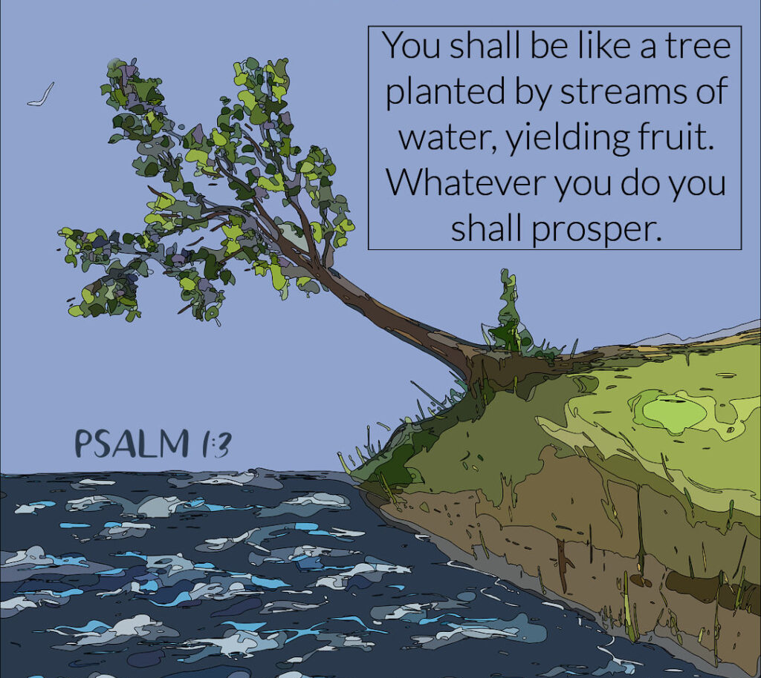
Graduating Class of 2026

Avynn Reese Thorson  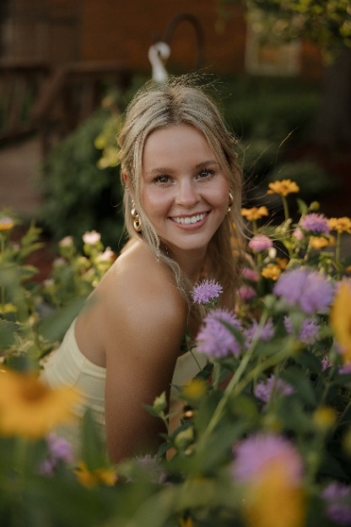  Daughter of Jason & Haley Thorson  Future plans:  To attend The University of North Dakota (UND) for Marketing and Communications  Favorite Church Memory: After attending her younger brother's baptism at church, the church pastor later visited their home and Avynn wondered how she got to their house because she understood the pastor to be Jesus. | Reighan Annalise Wavra  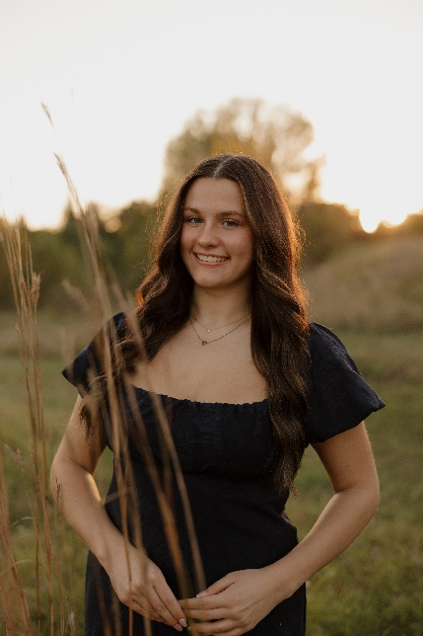  Daughter of Kent  & Holly Wavra  Future plans:  To attend The University of North Dakota (UND) for Graphic Design  Favorite Church Memory: Writing pretend sermon notes as a little girl because it looked like fun; singing Silent Night to candlelight on Christmas Eve; and participating in acts of service like the Greater Grand Forks Feed My Starving Children Mobile Pack.
Sophie Grace Pecka    Daughter of Troy & Patty Pecka  Future plans:  To attend The University of North Dakota (UND) for Nursing  Favorite Church Memory: Celebrating my confirmation with my fellow confirmands, the members of the church and my family. | Kadence Marie Korynta    Daughter of Josh & Angel Korynta  Future plans: To attend Northland for nursing and then eventually continue for higher education.  Favorite Church Memory:  Taking part in the youth trip to Montana.
Congratulations to the class of 2026!
Avynn, Reighan and Sophie are all graduating from East Grand Forks Senior High and Kadence is graduating from Fisher High School. We cannot wait to see what the future holds for these beautiful ladies. Congratulations and may God bless all your future endeavors!

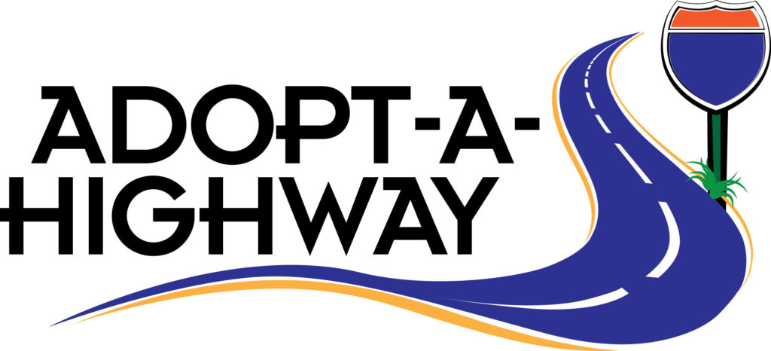
The Lord God took the man and put him in the garden of Eden to work it and keep it. Genesis 2:15
Adopt a Highway celebrates 36 years of success in keeping Minnesota highways clean, beautiful, and safe. More than 1,680+ Adopt a Highway groups volunteered and picked 28,900 bags of trash in 2024. Volunteers spent 80,600 plus hours picking up litter on 1000 segments of state roadways available for adoption. Thanks to the dedication of Adopt a Highway volunteers and their organizations, MNDOT is able to use the resources, that would have otherwise been used to pick up litter, for highway improvement and safety projects.
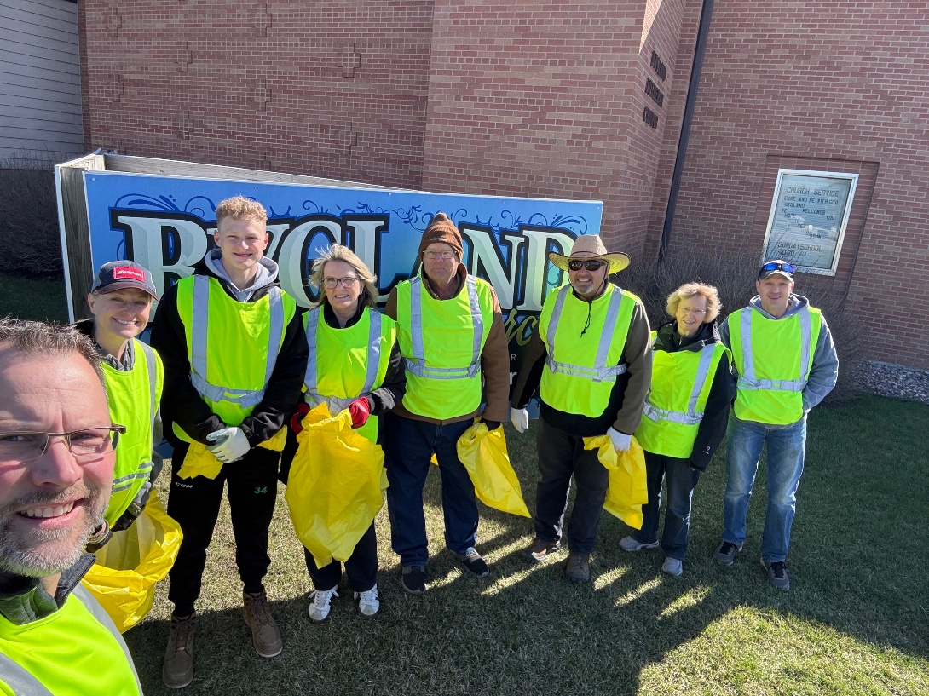
Bygland Lutheran Church and Youth Group/Sunday School have been partnering in this program with the state for over 18 years. That is amazing! We celebrate all of those who have taken time to volunteer throughout the years in serving our state, community, and church with this endeavor. Thank you to all of those who participated this past Saturday, April 25, 2026: Steve Moe, Kent, Holly, & Zach Wavra, Marsha Ketring, Jeff Millar, Linda & Alan Halvorson. It was good to be together, serving with our families, friends, and neighbors. A special thank you to Jeff Millar for providing door prizes for everyone and to Kent & Holly Wavra for providing doughnuts and bottled water.
All friends, neighbors, and parish members are welcome to participate in our program. Mark your calendars for our next collection date: Saturday, September 12th, 2026 @ 10 a.m. Participants will meet at the Bygland Lutheran Church, south door. All our asked to dress accordingly and to wear gloves and closed-toed shoes.

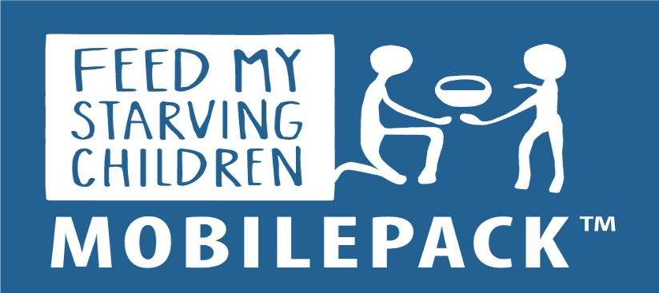
“A generous person will prosper. Whoever refreshes others with be refreshed.” Proverbs 11:25
FACT: Across the globe, hunger kills 1 person every 4 seconds.
FMSC is a non-profit, Christian organization that exists solely to offer reprieve for starvation impacted communities. $106 provides enough meals to feed a child 1 meal per day for a year. That’s less than 30 cents per meal.
Bygland Lutheran Church Sunday school has been a proud fundraising partner and mobile pack volunteer group for the past 14 years. This year we are even more excited to share we served with the largest group of volunteers to date! WOW!
So happy to be serving the Savior TOGETHER with each of YOU!
The Bygland Lutheran Church Sunday school wants to thank all of the individuals that supported their efforts in assisting with the success of the Greater Grand Forks Feed My Starving Children Mobile Packing Session which was held at the Minnkota Power building in Grand Forks, Friday, April 24th and Saturday, April 25th, 2026. Thank you for saying “yes” to Feeding God’s starvation impacted children with us ~ whether by purchasing and filling up “Mission Money – M & M” tubes to aid in paying for the food that gets packed at the sessions; or by volunteering as part of the packing session itself; and/or by simply praying. This event and its impacts would not be possible without the help and support of each of you!
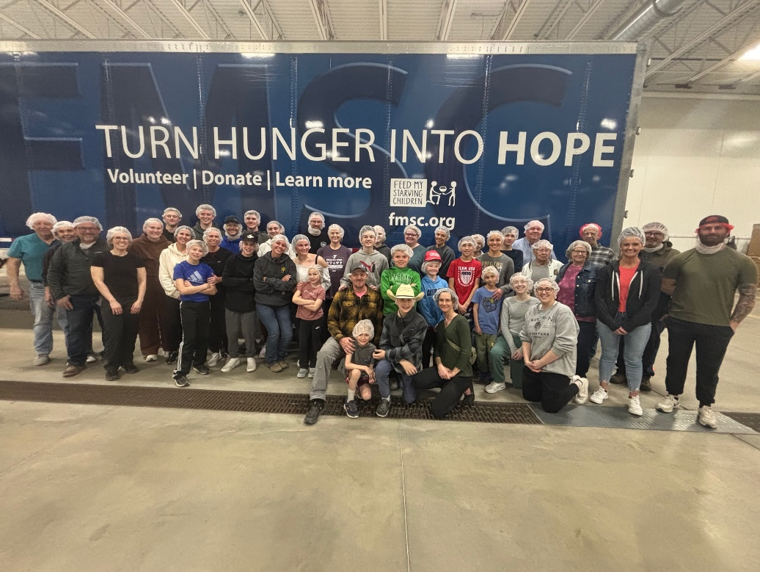
Friday, April 24th, 2026 Greater Grand Forks FMSC Mobile Packing Session BLCSS Volunteers:
Crystal & Justin Kahl, Jeff Millar, Arlet Phillips, Myron Wardner, Randy Moe, Rachel, Owen, & Emma Traub, Jim & Marsha Ketring, Laura, Brian, & Logan Wurden, Laura & Jackson Arnold, Becky & Layne Egeland, Casey, Amanda, Grayson, Weston, Paxton, & Edison Holweger, Kent, Holly, Zach, & Reighan Wavra, Morgan McDonald, Seth Aaker, Avynn & Hayes Thorson, Becky, Bryn & Luke Hanson, Danny, Bethany, Aiden, and Adlee Abrahamson, Kari & Kevin Jeuch, and Tom & Robbi Kovarx

Another Sunday school year has come to a close here at Bygland Lutheran Church. The season ended with the students sharing about what they learned in Sunday school. Each student added their own personal flare into sharing what they learned, making their presentations very enjoyable to listen to. They also worked on making guardian angels to take home to remind them of God’s special messengers who tell them about Jesus. Student participation and attendance awards, along with teacher recognitions, were presented during the 11:00 a.m. church service. What a blessing our students and staff are!

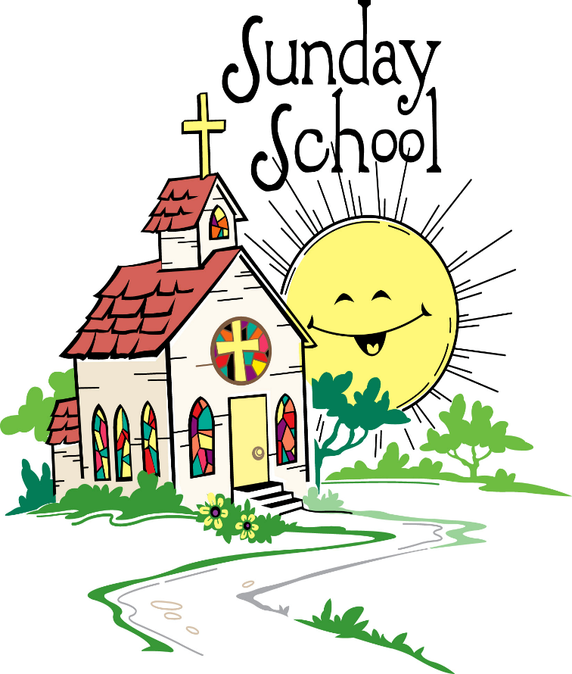
Thank you to each of the Sunday school families and to the congregation for all the support and generosity in making our program as successful as it is. We couldn’t do it without you!
A special thank you to Chris Egeland for making our Easter breakfast a continued tradition here at Bygland Lutheran Church.
Another special thank you to all of the members who supported our Feed My Starving Children service project ~ those who purchased and filled M & M tubes; those who packed food at the packing event; and those who prayed for the children receiving this food. What an amazing project to be a part of!
We look forward to another fun Sunday school season starting with Rally Sunday on Sunday, September 13, 2026 at 10:00 a.m. If you have a child that is new to our program and/or congregation, please contact Holly Wavra, (218) 893-4261 for more information on getting registered.

Proverbs 22:6
“Train up a child in the way he should go: and when he is old, he will not depart from it.”

